**COMP 3123 – Full Stack Development – Lab 1**

* JavaScript Refresher Exercises

**Developer Note:**

* Answer any 4 of the JavaScript exercises below
* Try to solve the problems without using search engines or stack overflow for the solutions.

**Exercise 1:**

***Write a JavaScript program to capitalize the first letter of each word of a given string.***

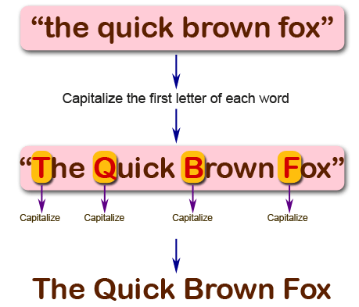

**function capitalizeWords(str) {**

**return str.split(" ")**

**.map(word => word.charAt(0).toUpperCase() + word.slice(1))**

**.join(" ");**

**}**

**console.log(capitalizeWords("comp3123 lab exercise one"));**

**Exercise 2:**

***Write a JavaScript program to find the largest of three given integers.***

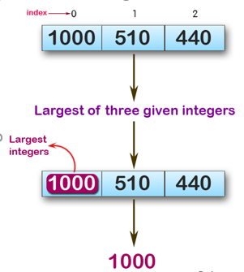

console.log(max (1,0,1));

console.log(max (0,-10,-20));

console.log(max (1000,510,440));

**Sample Output:**

1  
0  
1000

**function max(x, y, z) {**

**return Math.max(x, y, z);**

**}**

**console.log(max(1, 0, 1));**

**console.log(max(0, -10, -20));**

**console.log(max(1000, 510, 440));**

**Exercise 3:**

*Write a JavaScript program to move last three character to the start of a given string. The string length must be greater or equal to three****.***

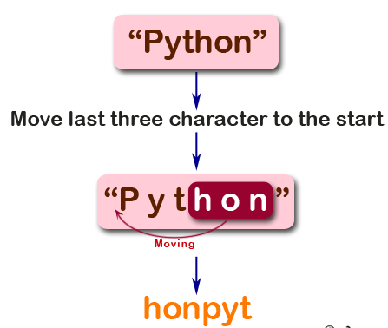

console.log(right("Python"));

console.log(right("JavaScript"));

console.log(right("Hi"));

**Sample Output:**

honPyt  
iptJavaScr  
Hi

**function right(str) {**

**return str.length >= 3**

**? str.slice(-3) + str.slice(0, str.length - 3)**

**: str;**

**}**

**console.log(right("Python"));**

**console.log(right("JavaScript"));**

**console.log(right("Hi"));**

**Exercise 4:**

*Write a JavaScript program to find the types of a given angle.*

Types of angles:  
• Acute angle: An angle between 0 and 90 degrees.  
• Right angle: An 90 degree angle.  
• Obtuse angle: An angle between 90 and 180 degrees.  
• Straight angle: A 180 degree angle.

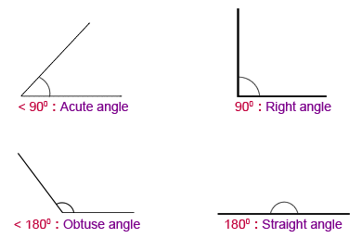

console.log(angle_Type(47))

console.log(angle_Type(90))

console.log(angle_Type(145))

console.log(angle_Type(180))

**function angle_Type(angle) {**

**if (angle > 0 && angle < 90) return "Acute angle";**

**if (angle === 90) return "Right angle";**

**if (angle > 90 && angle < 180) return "Obtuse angle";**

**if (angle === 180) return "Straight angle";**

**return "Invalid angle";**

**}**

**console.log(angle_Type(47));**

**console.log(angle_Type(90));**

**console.log(angle_Type(145));**

**console.log(angle_Type(180));**

**Exercise 5:**

*Write a JavaScript program to find the maximum possible sum of some of its k consecutive numbers (numbers that follow each other in order.) of a given array of positive integers.*

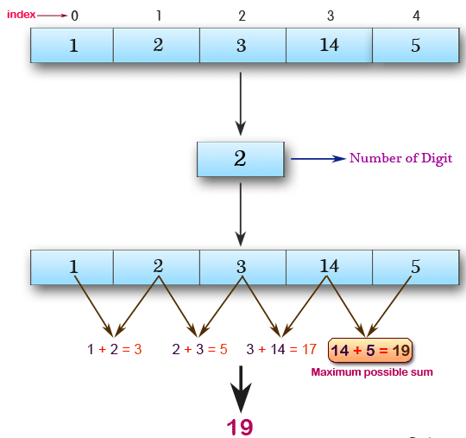

console.log(array_max_sum([1, 2, 3, 14, 5], 2))

console.log(array_max_sum([2, 3, 5, 1, 6], 3))

console.log(array_max_sum([9, 3, 5, 1, 7], 2))

**Sample Output:**

19  
12  
12

**function array_max_sum(arr, k) {**

**let maxSum = 0;**

**for (let i = 0; i < k; i++) {**

**maxSum += arr[i];**

**}**

**let currentSum = maxSum;**

**for (let i = k; i < arr.length; i++) {**

**currentSum += arr[i] - arr[i - k];**

**if (currentSum > maxSum) {**

**maxSum = currentSum;**

**}**

**}**

**return maxSum;**

**}**

**console.log(array_max_sum([1, 2, 3, 14, 5], 2));**

**console.log(array_max_sum([2, 3, 5, 1, 6], 3));**

**console.log(array_max_sum([9, 3, 5, 1, 7], 2));**